CCC

New Generation Platform

IOP-AI1 AND FTA-AI1x

Hardware Design Document
Rev 1.0

27th January 2015

Ownership Disclaimer
This document contains proprietary and confidential material that is the sole property of Compressor Controls Corporation. The information contained herein is intended for internal use by Compressor Controls Corporation employees and is not intended for distribution outside of the company. As an unpublished work of trade secrets, the recipient shall keep this document confidential. Any re-use, copying, or distribution, either in whole or in part, of this material without the express written consent of Compressor Controls Corporation is strictly forbidden.
Copyright © 2015 by Compressor Controls Corporation. All rights reserved.

Revision History

Rev. | Date | Revised By | Change Description
1.0 | 27-Jan-15 | Muthuvelu.D | Initial Release

Approvals

Approved by: Date: _____________

TABLE OF CONTENTS

1 Introduction 6
1.1 Purpose 6
1.2 Audience 6
1.3 Scope 6
1.4 Acronyms 6
1.5 References 6
2 General Description 7
2.1 Board features 8
2.2 Implementation block diagram 9
2.3 Description of functional Blocks 10
2.3.2 Power Architecture 10
2.3.2 Microcontroller Daughter Board 11
2.3.3 Analog input 11
2.3.5 CPLD 12
2.3.6 HART Modem 13
3 CAD Tools 22
3.1 Schematic Design Tool 22
3.2 Board Layout Design 22
4 PCB Details 22
4.1 PCB Stack-up 22
5 Connectors 23
5.1 IOP – AI1 to Backplane 23
5.2 IOP-AI1 to MPC5534 Daughter board 23
5.3 FTA – AI1 to Backplane 23
5.4 FTA – AI1 (Terminal Blocks) 23
5.5 IOP-AI1 BACKPLANE SIGNALS 24
5.6 FTA-AI1 BACKPLANE SIGNALS 27

TABLE OF FIGURES

Figure 1: IOP-AI1 to FTA 7
Figure 2: IOP-AI1 BLOCK DIAGRAM 9
Figure 3: Block Diagram of Power architecture 10
Figure 4: AD629 11
Figure 7: Frequency Shift Keying (FSK) 13
Figure 8: Two Communication Channels 14
Figure 9: Primary and Secondary Masters 15
Figure 10: Point-to-Point Configuration 15
Figure 11: Multidrop Configuration 16
Figure 12: HART Master Interface Circuit 17
Figure 13: Capacitive coupling 19
Figure 14: HART Implementation at analog input side 20
Figure 15: HART Slave Interface Circuit 20
Figure 16: HART Implementation at analog output side 21
Figure 17: PCB Stack-up 22

Introduction

Purpose
The purpose of this document is to describe the hardware design details of the IOP-AI1 and FTA-AI1. The document is prepared based on product requirement specifications and hardware requirement specifications prepared for IOP-AI1 and FTA-AI1.

Audience
The intended users of this document are hardware developers, software developers, test engineers, project leaders / program managers and management of Mindteck and Compressor Controls Corporation.

Scope
The scope of this document is to describe the hardware design details of the IOP-AI1 and FTA-AI1. It includes the components chosen, power consumption, layout guidelines and all other aspects of the design.

Acronyms
Acronym | Definition
NGP | New Generation Platform
IOP-AI1 | Input / Output Processor Analog Input module
FTA-AI1 | Field Termination Card Analog Input module
NV-RAM | Non volatile - RAM
HART | Highway addressable remote transducer

References
[1] Detailed Functional Specification for NGP Hardware, Part 1, Rev-3
[2] System Study for New Generation Platform Electronics and Bring-up, Rev-1

General Description

IOP ANALOG INPUT (IOP-AI1 AND FTA-AI1) are used for processing analog signals (4 to 20mA).There will be a maximum of 6 pairs (A,B Duplex) in NGP system. Each board has the capability to handle 16 analog inputs with HART protocol support.

FTA-AI1-These are the field terminal cards where all the field loads are connected to. These are electrically interfaced to IOP-AI1. The number of FTC in NGP system is same as the number of IOP pairs.

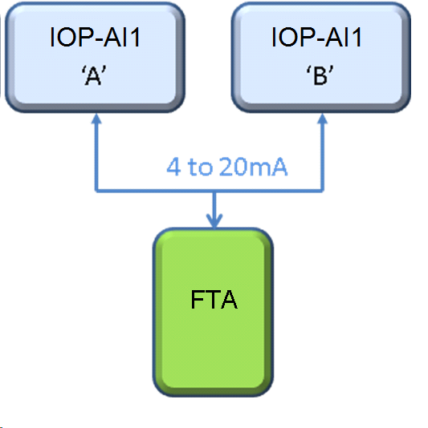

Figure 1: IOP-AI1 to FTA

Board features

IOP-AI1 card has the following features

- Freescale processor MPC5534 based daughter board.
- Ether-CAT (ET1100) bus communications.
- Supports general board diagnostics (Voltage, temperature)
- Hot-swap capability
- Development / test port facility (JTAG, Nexus, logic analyzer etc)

- Analog Inputs (16 No’s)

- Isolated to each other’s.
- Resolution: 16-bit minimum
- Accuracy (0.1%)
- SPI EEPROM for calibration data
- Indication LED’S
- Ability to extract HART information from all signals and provide to external systems

FTA-AI1x card shall have the following hardware requirements on board,
Analog Inputs (16 Channels per board)
FTA-AI11

- Thirteen channels – Loop Powered only.
- Three channels - External OR Loop powered options.
- Three channels - 4-20 mA, or 1-5V, switchable at the FTA w/ 250ohm resistor

FTA-AI12

- All sixteen channels – Loop Powered only.
- All channels- 4-20 mA, or 1-5V, switchable at the FTA w/ 250ohm resistor

Implementation block diagram
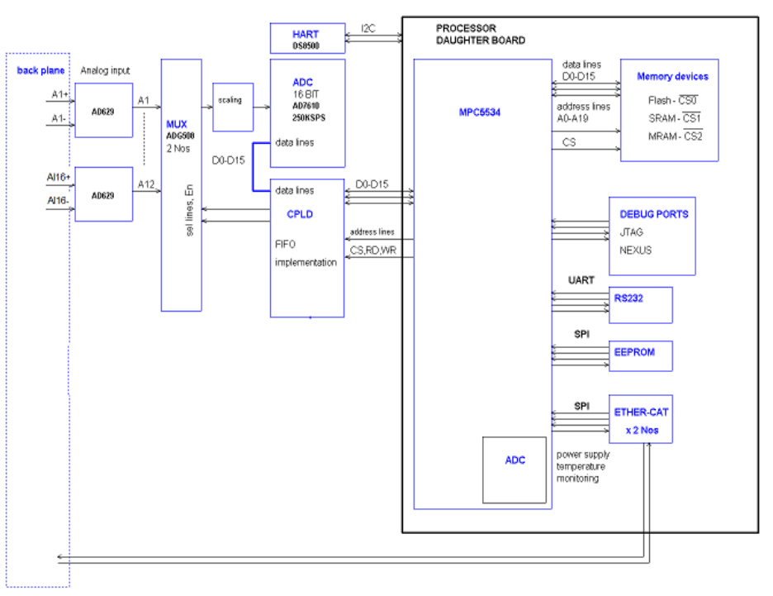

Figure 2: IOP-AI1 BLOCK DIAGRAM

Description of functional Blocks

2.3.2 Power Architecture

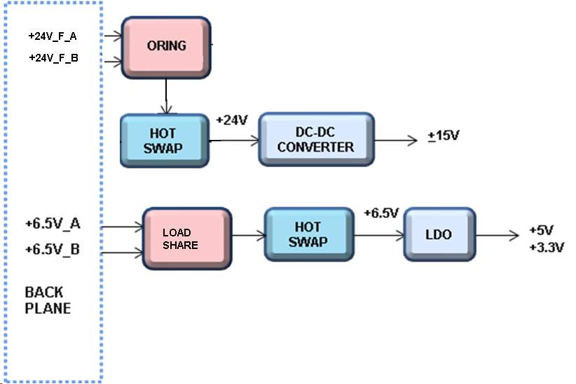

Figure 3: Block Diagram of Power architecture

- Both 24V_F and +6.5V A and B (Active oring) power supplies are hot swappable.
- Enabled through short pin (AirMax connectors).
- +24V is used for generating +15V for ADC section (analog inputs)
- +5V and +3.3V (Digital Supplies) are generated from +6.5V LDO.

2.3.2 Microcontroller Daughter Board

Freescale MPC5534 microcontroller based board with memory interfaced SRAM- 512K x16, MRAM- 1Mx16, NOR FLASH – 512K x16 and SPI EEPROM.
A CPLD is used for health monitoring and duplex switching. The daughter board is interfaced to IOP-AI1 CPLD through EBI bus.16 bit data bus and 13 bit address lines. Voltage, temperature and other diagnostics are performed by MPC5534 processor. Supports ether-cat (ET1100) bus communications.

2.3.3 Analog input

Analog inputs (16 Differential pairs) coming from FTA are isolated to each other (isolation voltage: +250V) using AD629. (Converts differential to single ended).

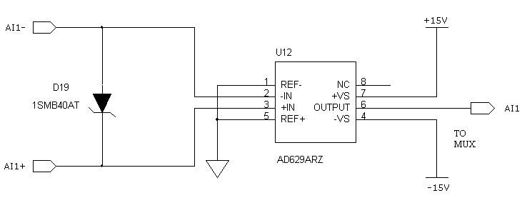

Figure 4: AD629

After AD629 16 analog signals are muxed using multiple 8 channel analog mux’s.The channel is chosen by CPLD. Dedicated channels are connected to voltage references for testing.

ADC

16-bit 250KSPS AD7610 is used with parallel interface to CPLD in order to implement FIFO (To achieve 1mS conversion time).

2.3.5 CPLD

- Part No: EPM2210F256I5N
- MAX II CPLD 2210 Logic elements with 204 I/O’s support.
- Package 256-FBGA
- Functions
- Read ADC Channels and store the data in internal FIFO
- Control DAC’S
- Control HART mux channels.
- Control front panel LEDs.
- Communicate with MPC5534 through parallel 13-bit address and 16-bit data.

2.3.6 HART Modem

Introduction

“HART” is an acronym for Highway Addressable Remote Transducer. The HART Protocol makes use of the Bell 202 Frequency Shift Keying (FSK) standard to superimpose digital communication signals at a low level on top of the 4-20mA.
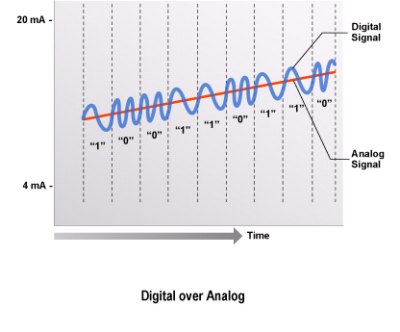
Figure 5: Frequency Shift Keying (FSK)
This enables two-way field communication to take place and makes it possible for additional information beyond just the normal process variable to be communicated to/from a smart field instrument. The HART Protocol communicates at 1200 bps without interrupting the 4-20mA signal and allows a host application (master) to get two or more digital updates per second from a smart field device. As the digital FSK signal is phase continuous, there is no interference with the 4-20mA signal.
HART technology is a master/slave protocol, which means that a smart field (slave) device only speaks when spoken to by a master. The HART Protocol can be used in various modes such as point-to-point or multidrop for communicating information to/from smart field instruments and central control or monitoring systems.
HART Communication occurs between two HART-enabled devices, typically a smart field device and a control or monitoring system. Communication occurs using standard instrumentation grade wire and using standard wiring and termination practices.
The HART Protocol provides two simultaneous communication channels: the 4-20mA analog signal and a digital signal. The 4-20mA signal communicates the primary measured value (in the case of a field instrument) using the 4-20mA current loop - the fastest and most reliable industry standard. Additional device information is communicated using a digital signal that is superimposed on the analog signal.
The digital signal contains information from the device including device status, diagnostics, additional measured or calculated values, etc. Together, the two communication channels provide a low-cost and very robust complete field communication solution that is easy to use and configure.
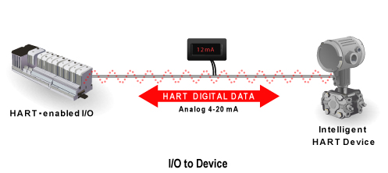
Figure 6: Two Communication Channels
The HART Protocol provides for up to two masters (primary and secondary). This allows secondary masters such as handheld communicators to be used without interfering with communications to/from the primary master, i.e. control/monitoring system.
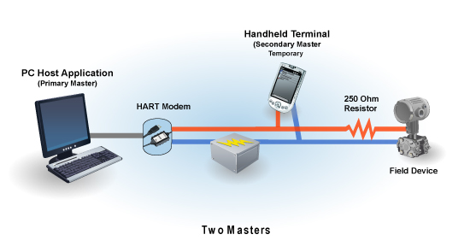
Figure 7: Primary and Secondary Masters
The HART Protocol permits all digital communication with field devices in either point-to-point or multidrop network configurations:
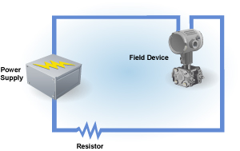
Figure 8: Point-to-Point Configuration
Multidrop Configuration
There is also an optional "burst" communication mode where a single slave device can continuously broadcast a standard HART reply message. Higher update rates are possible with this optional burst communication mode and use is normally restricted to point-to-point configuration.

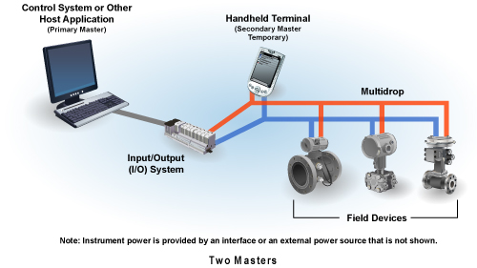
Figure 9: Multidrop Configuration

HART Implementation at analog input side

Master Device
The HART Master interfaces to the network as a voltage source, as illustrated in simplified form in Figure 13. The network is driven by a low output impedance (600 ohm or less) voltage amplifier circuit that can be switched to a high impedance state using RTS. The output of the voltage amplifier needs to be high impedance while the HART Master receives, to insure high input impedance for the receiver.

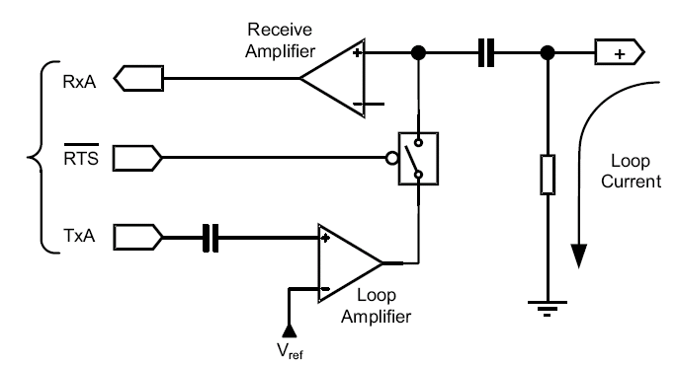
Figure 10: HART Master Interface Circuit

Transmitting the HART Signal
During a HART message transmission from the Master, the output impedance of the voltage source is quite low (0 −600 ohm). However during reception of a HART message, the input impedance of the receive section must be quite high. Therefore, the transmitter section must be disabled when not active (nRTS = “High”).
Several methods can be used to achieve a high output impedance of the transmitter while nRTS is inactive. One method is choosing an op−amp with an “active low” current programming resistor that will basically “turn off” the op−amp during receive operations. A second method can be implemented with a correctly biased discrete FET in series with the output stage. Lastly, a discrete solid state relay with characteristically low “on resistance” can be used.
All three above techniques will provide an adequate solution for the impedance requirements. However, only the third solution will allow proper circuit operation per the “bit−error−rate” requirements and does not need to be powered by a dual supply
Under worse case conditions, a transmitter could dynamically change from 4 − 20 mA and a HART Master could have as much as 1K ohm of loop resistance. This results in (20 – 4)10−3 x 1.103 = 16 V p−p low frequency carrier with HART super imposed. The transmit switch must be designed to prevent this 16 V p−p signal from sinking current through the HART transmitter’s output stage. Any clipping of the 16 Vp−p signal through the HART transmitter or the use of transient suppressors will result in the clipping of the superimposed HART signal. The last solution will block and not clip the 16 Vp−p process signal and will not corrupt the input impedance. The third solution can be implemented easily as shown in Figure 13.
Receiving the HART Signal
All HART receivers require non−disruptive coupling to the network current loop. This connection can be made with capacitive or galvanic coupling without corruption of the process loop current.
The master can be connected across the field instrument or the current sense resistor regardless of the polarity or grounding configuration
The current sense resistor is considered an integral part of a HART Master. In operation, a HART message response from a Slave is superimposed on the 4−20 mA current loop. The Slave’s 1 mA p−p HART signal is dropped across the Master’s sense resistor. For a typical sense resistor of 250 ohm, one can expect 250 mVp−p signal extracted from a HART Slave device. A HART Master can have a sense resistor ranging from 230 ohm to 600 ohm.
A HART Master must be able to receive voltage signals that are developed across the sense impedance. In addition, it must be able to apply a transmit signal across the current sense impedance. In some cases the Master will signal across the field device as well. In all cases, the presence of the HART Master must not disrupt the analog signaling of the process loop. Therefore, the HART signals must be non−intrusively coupled from the current sense resistor to the Master through one of the various coupling techniques.
Coupling to the network is most commonly done with capacitors and transformers. The simplest form of capacitor coupling is used as shown.
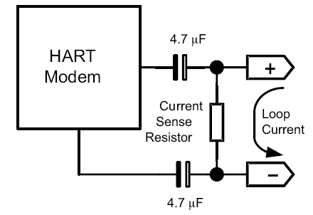
Figure 11: Capacitive coupling
At analog input side two differential analog mux are used for 12 inputs. The select lines are controlled by CPLD. The MPC5534 controls the HART modem through SC16IS750 I2C to UART (full modem) converter.
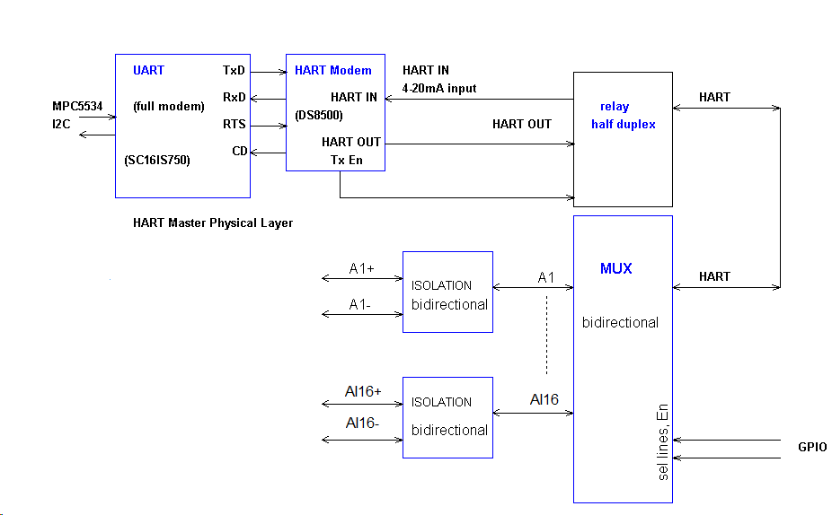
Figure 12: HART Implementation at analog input side
HART Implementation at analog output side

Slave Device
The Slave interface to the network is typically a current regulator, as illustrated in simplified form in Figure 16. Its output current is controlled by varying a much smaller current into an op−amp summing junction. This junction is a convenient point at which to sum the analog and digital signals, thereby achieving superposition of the digital signal onto the analog. The digital transmit signal (TxA) is capacitively coupled into the summing junction, to preserve DC accuracy of the 4−20 mA analog signal. Also shown in Figure 19 is the receive path, consisting of a capacitor from the collector of the current regulator transistor to a high−impedance amplifier. Both the receive amplifier and the transmit current source should present a high impedance (greater than 100K ohm).
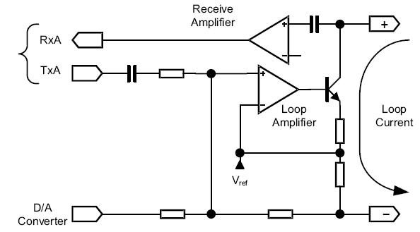
Figure 13: HART Slave Interface Circuit
Transmitting the HART Signal
The amplitude of TxA is nominally 500 mVp−p. The HART Physical Layer requires the Slave to modulate the loop with a 1 mA p−p signal. The amplitude of modulation of the loop current will have to be adjusted before the amplifier in the current loop regulator or at the regulator itself.
It is recommended that the amplitude can be adjusted with voltage gain circuits. Using a small series capacitance to attenuate the signal may cause distortion of the transmitted signal.
Receiving the HART Signal
All HART receivers require non−disruptive coupling to the network current loop. This connection can be made with capacitive or inductive coupling without corruption of the process loop current. Typically a HART Slave uses a small value (2.2 nF) capacitor to couple an adequate signal level to the receive filter.
Analog outputs 4 nos isolated to each other are implemented for HART slave. MPC5534 controls HART modem through isolated I2C (ADuM1250).
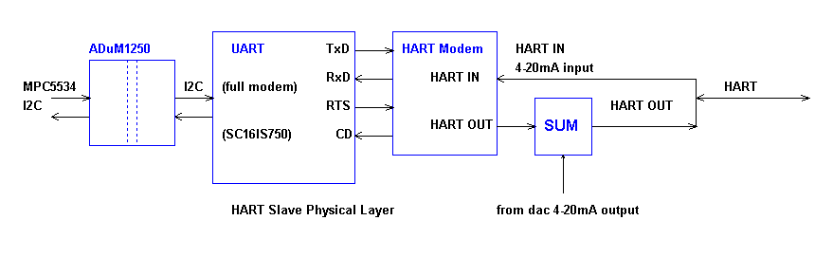
Figure 14: HART Implementation at analog output side

CAD Tools

Schematic Design Tool

Schematic entry is done PADS LOGIC 9.3.

Board Layout Design

PCB is designed in PADS LAYOUT 9.3.

PCB Details

No of layers : 8 with impedance controlled board.

PCB Stack-up

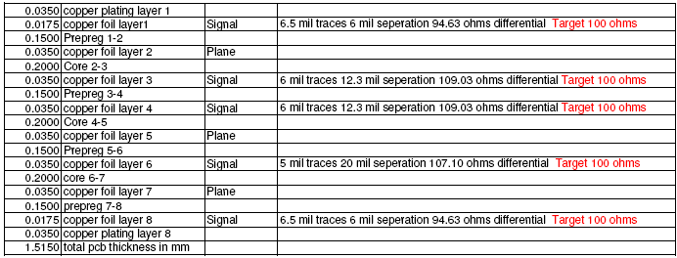

Figure 15: PCB Stack-up

Connectors

IOP – AI1 to Backplane

Make | Part No | Description
FCI | 10045267-111LF | 72-PIN Air-Max
FCI | 10028917-001LF | 4-PIN Power connector
FCI | 10045597-107LF | GUIDE PIN

IOP-AI1 to MPC5534 Daughter board

Make | Part No | Description
Samtec | QTE-040-02-X-D-A | 80-PIN,Male Shroud Contacts

FTA – AI1 to Backplane

Make | Part No | Description
FCI | 10056098-1050011LF | 150-PIN Air-Max
FCI | 10045597-107LF | GUIDE PIN

FTA – AI1 (Terminal Blocks)

Make | Part No | Description
PHOENIX | 1777235 | 1 x 18,5.08mm,TH

IOP-AI1 BACKPLANE SIGNALS

Pin No. | Signal Name | Description
J1.F1 | +24V_AN_A | Analog Power
J1.F2 | +24V_AN_A | Analog Power
J1.I1 | +24V_AN_B | Analog Power
J1.I2 | +24V_AN_B | Analog Power
J3.E4 | +6.5V_LOAD-SHARED | +6.5V_LOAD-SHARED
J1.G1 | 24V_AGND | Analog ground
J1.H1 | 24V_AGND | Analog ground
J1.G2 | 24V_AGND | Analog ground
J1.H2 | 24V_AGND | Analog ground
J1.C4 | AI1- | IO Pair between IOP and FTC
J1.B4 | AI1+ | IO Pair between IOP and FTC
J1.H4 | AI2- | IO Pair between IOP and FTC
J1.I4 | AI2+ | IO Pair between IOP and FTC
J1.B5 | AI3- | IO Pair between IOP and FTC
J1.A5 | AI3+ | IO Pair between IOP and FTC
J1.D5 | AI4- | IO Pair between IOP and FTC
J1.E5 | AI4+ | IO Pair between IOP and FTC
J1.H5 | AI5- | IO Pair between IOP and FTC
J1.G5 | AI5+ | IO Pair between IOP and FTC
J1.B6 | AI6- | IO Pair between IOP and FTC
J1.C6 | AI6+ | IO Pair between IOP and FTC
J1.F6 | AI7- | IO Pair between IOP and FTC
J1.E6 | AI7+ | IO Pair between IOP and FTC
J1.H6 | AI8- | IO Pair between IOP and FTC
J1.I6 | AI8+ | IO Pair between IOP and FTC
J1.B7 | AI9- | IO Pair between IOP and FTC
J1.A7 | AI9+ | IO Pair between IOP and FTC
J1.D7 | AI10- | IO Pair between IOP and FTC
J1.E7 | AI10+ | IO Pair between IOP and FTC
J1.H7 | AI11- | IO Pair between IOP and FTC
J1.G7 | AI11+ | IO Pair between IOP and FTC
J1.B8 | AI12- | IO Pair between IOP and FTC
J1.C8 | AI12+ | IO Pair between IOP and FTC
J3.B1 | AI13- | IO Pair between IOP and FTC
J3.A1 | AI13+ | IO Pair between IOP and FTC
J3.D1 | AI14- | IO Pair between IOP and FTC
J3.E1 | AI14+ | IO Pair between IOP and FTC
J3.H1 | AI15- | IO Pair between IOP and FTC
J3.G1 | AI15+ | IO Pair between IOP and FTC
J3.B2 | AI16- | IO Pair between IOP and FTC
J3.C2 | AI16+ | IO Pair between IOP and FTC
J3.I5 | ANB
J3.F7 | CONTROL_FB_B
J3.C7 | DGND | DGND
J3.I7 | DGND | DGND
J3.A8 | DGND | DGND
J3.G8 | DGND | DGND
J3.B8 | ESC1_EBUS[0]-RX- | Ethercat signal
J3.C8 | ESC1_EBUS[0]-RX+ | Ethercat signal
J3.A7 | ESC1_EBUS[0]-TX- | Ethercat signal
J3.B7 | ESC1_EBUS[0]-TX+ | Ethercat signal
J3.H8 | ESC2_EBUS[0]-RX- | Ethercat signal
J3.I8 | ESC2_EBUS[0]-RX+ | Ethercat signal
J3.G7 | ESC2_EBUS[0]-TX- | Ethercat signal
J3.H7 | ESC2_EBUS[0]-TX+ | Ethercat signal
J1.E4 | HOTSWAP_EN | Enable Hot swap
J3.I3 | IOP_SLOT_ID1 | IOP_SLOT_ID1
J3.A4 | IOP_SLOT_ID2 | IOP_SLOT_ID2
J3.D4 | IOP_SLOT_ID3 | IOP_SLOT_ID3
J3.C5 | IOP_SLOT_ID4 | IOP_SLOT_ID4
J3.E8 | IOP_TO_IOP_SRH2 | IOP_TO_IOP_SRH2
J3.E7 | IOP_TO_IOP_SRH3 | IOP_TO_IOP_SRH3
J3.F8 | PEER_CONTROL_FB | PEER_CONTROL_FB
J3.D7 | PEER_READY_FB | PEER_READY_FB
J3.D8 | READY_FB_B | READY_FB_B
J3.F3 | $$$8113 | CHASIS_NUM1
J3.D6 | $$$8164 | BACKPLANE_TYPE4
J3.C6 | $$$8174 | BACKPLANE_TYPE3
J3.B6 | $$$8176 | BACKPLANE_TYPE2
J3.A6 | $$$8177 | BACKPLANE_TYPE1
J3.I6 | $$$8236 | FTC_BD5
J3.H6 | $$$8244 | FTC_BD4
J3.G6 | $$$8245 | FTC_BD3
J3.F6 | $$$8247 | FTC_BD2
J3.E6 | $$$8248 | FTC_BD1
J3.F5 | $$$8337 | CHASIS_NUM4
J3.F4 | $$$8710 | CHASIS_NUM2
J3.G4 | $$$8729 | CHASIS_NUM3

FTA-AI1 BACKPLANE SIGNALS

Pin No. | Signal Name | Description
J2.K1 | +24V_A_HOT_EN | 24V Hot swap enable
J1.K10 | +24V_A_HOT_FEED | 24V Hot swap enable
J2.F2 | +24V_B_HOT_EN | 24V Hot swap enable
J1.F10 | +24V_B_HOT_FEED | 24V Hot swap enable
J1.O10 | +24V_MON_A_IOPA | 24V_A Analog Supply Monitor
J1.O9 | +24V_MON_A_IOPA | 24V_A Analog Supply Monitor
J2.J1 | +24V_MON_A_IOPB | 24V_A Analog Supply Monitor
J2.J2 | +24V_MON_A_IOPB | 24V_A Analog Supply Monitor
J1.L10 | +24V_MON_B_IOPA | 24V_B Analog Supply Monitor
J1.L9 | +24V_MON_B_IOPA | 24V_B Analog Supply Monitor
J2.G1 | +24V_MON_B_IOPB | 24V_B Analog Supply Monitor
J2.G2 | +24V_MON_B_IOPB | 24V_B Analog Supply Monitor
J2.D1 | 24V_AN_A | 24V_A Analog Supply
J2.D2 | 24V_AN_A | 24V_A Analog Supply
J2.E1 | 24V_AN_A | 24V_A Analog Supply
J2.E2 | 24V_AN_A | 24V_A Analog Supply
J2.A4 | 24V_AN_B | 24V_B Analog Supply
J2.B4 | 24V_AN_B | 24V_B Analog Supply
J2.A5 | 24V_AN_B | 24V_B Analog Supply
J2.B5 | 24V_AN_B | 24V_B Analog Supply
J2.A1 | AGND | Analog ground
J2.A2 | AGND | Analog ground
J2.B1 | AGND | Analog ground
J2.B2 | AGND | Analog ground
J2.C1 | AGND | Analog ground
J2.C2 | AGND | Analog ground
J2.H1 | AGND | Analog ground
J2.H2 | AGND | Analog ground
J2.I1 | AGND | Analog ground
J2.I2 | AGND | Analog ground
J1.M10 | AGND | Analog ground
J1.M9 | AGND | Analog ground
J1.N10 | AGND | Analog ground
J1.N9 | AGND | Analog ground
J2.A3 | AGND | Analog ground
J2.B3 | AGND | Analog ground
J1.E1 | AIN1- | IO Pair between IOP and FTC
J2.E4 | AIN1- | IO Pair between IOP and FTC
J1.D1 | AIN1+ | IO Pair between IOP and FTC
J2.D4 | AIN1+ | IO Pair between IOP and FTC
J2.H6 | AIN10- | IO Pair between IOP and FTC
J1.H3 | AIN10- | IO Pair between IOP and FTC
J2.G6 | AIN10+ | IO Pair between IOP and FTC
J1.G3 | AIN10+ | IO Pair between IOP and FTC
J2.K6 | AIN11- | IO Pair between IOP and FTC
J1.K3 | AIN11- | IO Pair between IOP and FTC
J2.J6 | AIN11+ | IO Pair between IOP and FTC
J1.J3 | AIN11+ | IO Pair between IOP and FTC
J2.N6 | AIN12- | IO Pair between IOP and FTC
J1.N3 | AIN12- | IO Pair between IOP and FTC
J2.M6 | AIN12+ | IO Pair between IOP and FTC
J1.M3 | AIN12+ | IO Pair between IOP and FTC
J1.H1 | AIN2- | IO Pair between IOP and FTC
J2.H4 | AIN2- | IO Pair between IOP and FTC
J1.G1 | AIN2+ | IO Pair between IOP and FTC
J2.G4 | AIN2+ | IO Pair between IOP and FTC
J1.K1 | AIN3- | IO Pair between IOP and FTC
J2.K4 | AIN3- | IO Pair between IOP and FTC
J1.J1 | AIN3+ | IO Pair between IOP and FTC
J2.J4 | AIN3+ | IO Pair between IOP and FTC
J1.N1 | AIN4- | IO Pair between IOP and FTC
J2.N4 | AIN4- | IO Pair between IOP and FTC
J1.M1 | AIN4+ | IO Pair between IOP and FTC
J2.M4 | AIN4+ | IO Pair between IOP and FTC
J1.F2 | AIN5- | IO Pair between IOP and FTC
J2.F5 | AIN5- | IO Pair between IOP and FTC
J1.E2 | AIN5+ | IO Pair between IOP and FTC
J2.E5 | AIN5+ | IO Pair between IOP and FTC
J1.I2 | AIN6- | IO Pair between IOP and FTC
J2.I5 | AIN6- | IO Pair between IOP and FTC
J1.H2 | AIN6+ | IO Pair between IOP and FTC
J2.H5 | AIN6+ | IO Pair between IOP and FTC
J1.L2 | AIN7- | IO Pair between IOP and FTC
J2.L5 | AIN7- | IO Pair between IOP and FTC
J1.K2 | AIN7+ | IO Pair between IOP and FTC
J2.K5 | AIN7+ | IO Pair between IOP and FTC
J1.O2 | AIN8- | IO Pair between IOP and FTC
J2.O5 | AIN8- | IO Pair between IOP and FTC
J1.N2 | AIN8+ | IO Pair between IOP and FTC
J2.N5 | AIN8+ | IO Pair between IOP and FTC
J2.E6 | AIN9- | IO Pair between IOP and FTC
J1.E3 | AIN9- | IO Pair between IOP and FTC
J2.D6 | AIN9+ | IO Pair between IOP and FTC
J1.D3 | AIN9+ | IO Pair between IOP and FTC
J1.L4 | AI13- | IO Pair between IOP and FTC
J2.L7 | AI13- | IO Pair between IOP and FTC
J1.K4 | AI13+ | IO Pair between IOP and FTC
J2.K7 | AI13+ | IO Pair between IOP and FTC
J1.O4 | AI14- | IO Pair between IOP and FTC
J2.O7 | AI14- | IO Pair between IOP and FTC
J1.N4 | AI14+ | IO Pair between IOP and FTC
J2.N7 | AI14+ | IO Pair between IOP and FTC
J2.E8 | AI15- | IO Pair between IOP and FTC
J1.E5 | AI15- | IO Pair between IOP and FTC
J2.D8 | AI15+ | IO Pair between IOP and FTC
J1.D5 | AI15+ | IO Pair between IOP and FTC
J2.H8 | AI16- | IO Pair between IOP and FTC
J1.H5 | AI16- | IO Pair between IOP and FTC
J2.G8 | AI16+ | IO Pair between IOP and FTC
J1.G5 | AI16+ | IO Pair between IOP and FTC
J2.A10 | FTC_BD1 | FTC_BD1
J2.B10 | FTC_BD2 | FTC_BD2
J2.A9 | FTC_BD3 | FTC_BD3
J2.B9 | FTC_BD4 | FTC_BD4
J2.A8 | FTC_BD5 | FTC_BD5
J1.A4 | GND | Ground
J1.B4 | GND | Ground
J1.A3 | GND | Ground
J1.B3 | GND | Ground
J2.A7 | GND | Ground
J2.B7 | GND | Ground

